

**Department of CSE**

**CSE209 Lab**

**Course Name: Electrical Circuits**

**Course Code: CSE209**

**Section No: 2**

**Experiment No: 01**

**Name of the Experiment:** Introduction to Circuit Elements and variables.

**Date of submission: 10/08/2021**

Student’s Name: Md Abdul Ahad Rifat

Student’s ID: 2020-1-60-215

**Submitted to**

Rashedul Amin Tuhin

Senior Lecturer

Department of Computer Science and Engineering

East West University

**Objectives:**

1. To get familiar with circuit variables (voltage and current) and circuit elements (voltage

Source and resistance).

2. To learn how to measure dc voltage across a circuit element using a voltmeter.

3. To learn how to measure dc current through a circuit element using an ammeter.

4. To learn how to measure resistance of a resistor using a multimeter.

5. To verify Ohm’s Law.

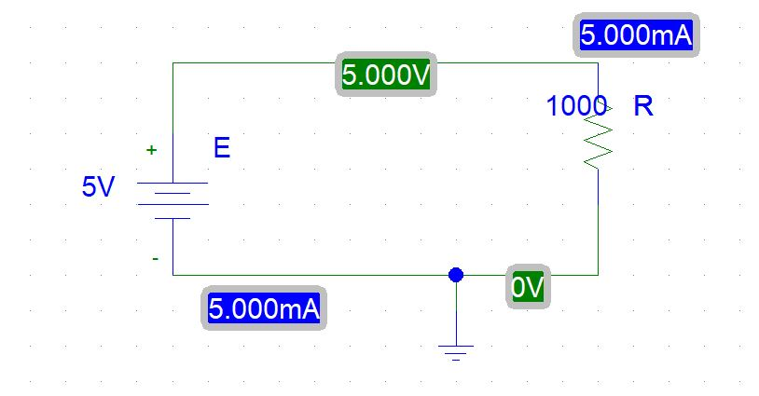**Circuit Diagram(s):**

**Figure 1. Circuit Diagram for Experiment 1**

**Experimental Datasheet:**

**Table 1 Experimental Datasheet**

|  |  |  |  |  |
| --- | --- | --- | --- | --- |
| **Observation**  **number** | **Set Value of**  ***E (V)*** | **Measured Value**  **of *V (V)*** | **Measured Value**  **of *I (mA)*** | **Measured Value**  **of *R (Ω)*** |
| 1 | 5 | 5 | 5 | 1000 |
| 2 | 6 | 6 | 6 |
| 3 | 7 | 7 | 7 |
| 4 | 8 | 8 | 8 |
| 5 | 9 | 9 | 9 |
| 6 | 10 | 10 | 10 |

**Post-Lab Report Questions and Answers:**

1. Theoretically calculate the values of me using measured values of V and R. Compare the theoretical values with the measured values and comment on any discrepancy.

**Answer:** After calculation theoretically, there was no discrepancy between the theoretical values and the measured values because the measured values was measured using Pspice Simulation Software.

1. Theoretically calculate the values of R from the measured values of V and I using Ohm’s law. Compare the calculated and measure values of R and comment on any discrepancy.

**Answer:**

We know that Ohm’s Law $V=IR$ or $R=\frac{V}{I}$

When V= 5V and I =5 mA = 0.005A then,

R = $\frac{5}{0.005}$ Ω

= 1000Ω

When V= 6V and I =6 mA = 0.006A then,

R = $\frac{6}{0.006}$ Ω

= 1000Ω

When V= 7V and I =7 mA = 0.007A then,

R = $\frac{7}{0.007}$ Ω

= 1000Ω

When V= 8V and I =8 mA = 0.008A then,

R = $\frac{8}{0.008}$ Ω

= 1000Ω

When V= 9V and I =9 mA = 0.009A then,

R = $\frac{9}{0.009}$ Ω

= 1000Ω

When V= 10V and I =10 mA = 0.01A then,

R = $\frac{10}{0.01}$ Ω

= 1000Ω

1. Compare the set value of E and the measured value of V and comment on any Discrepancy.

**Answer:**  There has been no changed between the set value E and measured value V because we are using Pspice Simulation Software. Here we will get the actual value of E an there was no discrepancy.

1. Plot V vs. I (taking I as independent variable) and fit a straight-line passing through the origin. From the plot determine the resistance of the supplied resistor using Ohm’s law.

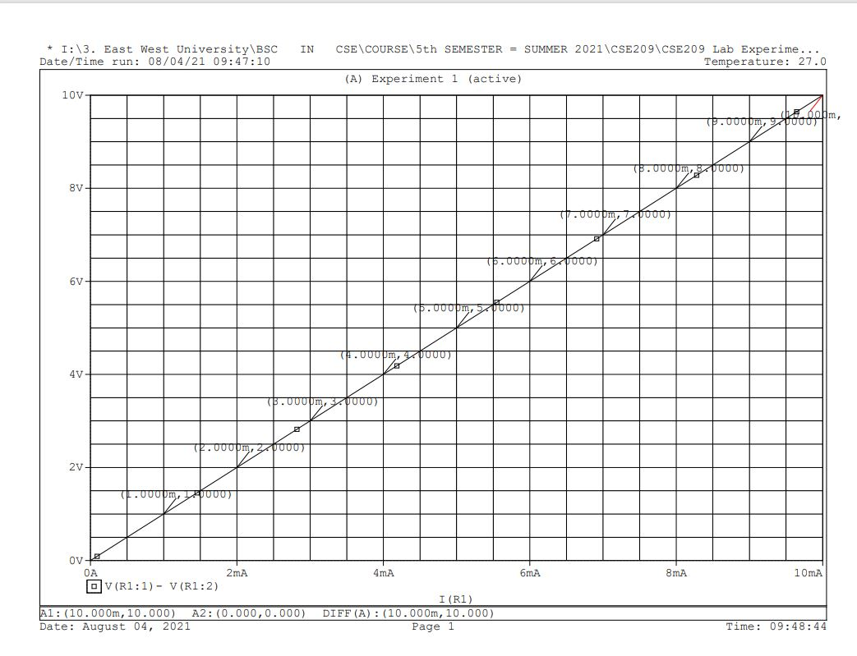**Graph:**

**Figure 2. I-V Characteristic Curve**

We used Ohm’s Law theoretically calculate R which is 1000Ω for different values of I and V .We use Pspice Simulation Software to create this graph.

1. Discuss how voltage or current is measured using a multi-range meter

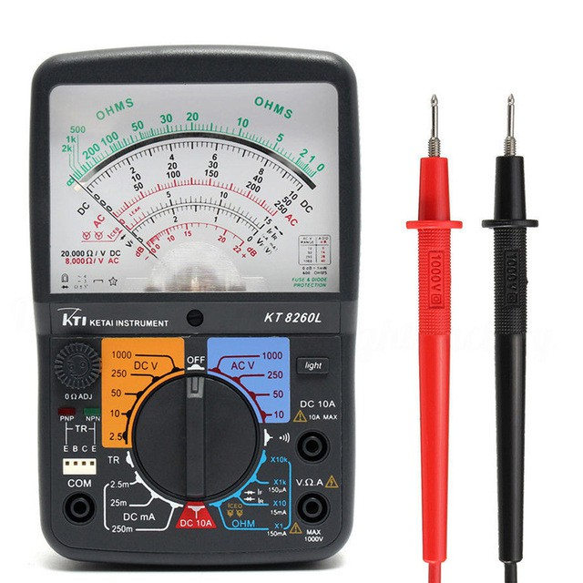**Answer:**  If we have a resistor and we want to measure the Current and Voltage then we need multi-range meter. Now we want to measure Voltage then we need multi-range voltmeter, we connect the voltmeter parallel with the resistor and connect the positive terminal with the positive side and connect the negative terminal with the black color wire or negative side, then we can measure the voltage. On the other hand if we want to measure Current then we need multi-range ammeter. We connect the ammeter series with the resistor, so we need to loose wire connection anywhere into the circuit and then we can measure the Current.

**Figure 3. Analog Multi-meter**

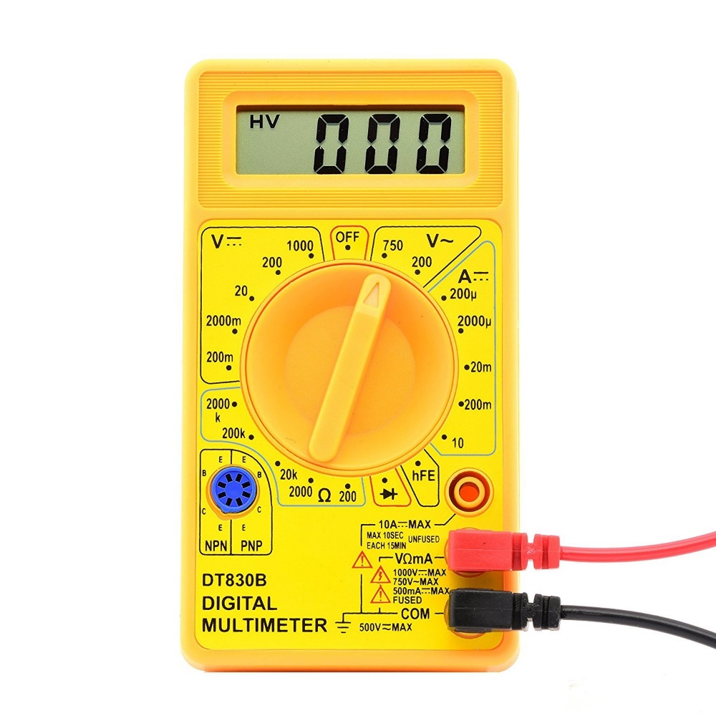

**Figure 4. Digital Multi-meter**

If we set the multi-meter nobbe 200v then we measure maximum 200v in across the resistor. Ammeter measurement type is also same. If we set the nobbe 20mA then we can measure maximum 20mA current remember one thing when we measure current in that time we need a series connection between circuit and multi-meter. Red wire means positive and black wire means common or negative.

**Conclusion:**

In real life if we did this experiment using hardware then we have gotten different value in voltage and current, but in a Pspice software we have gotten actual same value .The real work of this experiment is understanding the Ohm’s Law .In this experiment we can easily understand how ohm’s law work. If any time we do this experiment in reality we always remember resistor value will be high otherwise we will get a chance to get shock in a current.